CIT Overview 2024
(prev. year questions | optimal range 2016-21)

Table of Contents
Logic & Proofs 3
Counting 4
Algorithms 5
Number theory & Cryptography 5
Induction & Recursion 5
Set 6
Relation 6
Function 7
Graph 7
Binary Tree 8
Bonus :: Sample Question 8

Hyperlinked (click to follow above links)

Disclaimer
This is, by no means, any sort of suggestion. Just the curated set of topics derived from previous year’s questions, sorted with latest in preference, without any sorts of guaranty. Copyrighting is totally allowed under CC-O act. Also thanks to Mehedi Hasan and others for collaboration. Here, the star mark represents repetition rate! A bit of luck this time, I guess.
1) Further questions (2015 and earlier) are also available on rising flare. Feel free to check!
2) Red marked questions are out of syllabus, AFAIK.

Logic & Proofs
Let’s define…
- Propositional logic *
- Rules of inference *
- Modus ponens *
- Resolution *
- tautology
- contradiction

Let’s illustrate...
- What kind of problems are solved using discrete mathematics?
- Show and are logically equivalent *
- Translate the statement ∀x (C(x) v ∃y (C(y) ^ F(x, y))) into English, where C(x) is "x has a computer, "F(x, y) is "x and y are friends," and the domain for both x and y consists of all students in your school.
- Assume “For all positive integers n, and is greater than 4, then n² is less than 2”, is true. Use universal modus ponens to show that 100² < 2¹⁰⁰
- 8-Queen
- Let P(x) denote the statement "x > 3." What is the truth value of the quantification 3x P(x), where the domain consists of all real numbers?
- Show that the premises (p ^ q) V r and r → s imply the conclusion p V s.
- Find the truth table for (p → q) V ~ (p ↔ ~q)
- Validity of the argument:
S1 : All red meats contain cholesterol
S2 : No expensive food contain cholesterol
------------------------------------------------------------------
S : Red meat is not expensive
- What does logically equivalent of two compound propositions mean?
- Verify that the proposition is a contradiction
- (p^q) ^~ (p V q)
- (a V b) ^ [(¬a) ^ (¬b)]
- Prove that disjunction distributes over conjunction: that is, prove the distributive law pV (q^r) = (p V q) ^ (p V r) **
- explain the meaning of p, (p V r), (p ^ r) etc. (check books examples)
- interference rules with example
- Briefly describe Normal forms
- showing equivalent using truth tables (like 2) (check books examples)
- Write the following sentences in propositional symbolic form,
  - If I am not in a good mood or I am busy, do no disturb me
  - A program is readable only if it is well structured
  - There will be no exam tomorrow if the professor is out of the town or there is a strike
  - If the user enters a wrong password, his access is not granted even though he has paid his fees
  - Driving over 65 miles per hour is sufficient for getting a speeding ticket
  - If berries are ripe in the trial, hiking is safe if and only if grizzly bears have not been seen in the area.
- There are two signboards in front of a shopping mall. One says, "Good items are not cheap". The other one says, "Cheap Items are not good". Do the signboards say the same proposition? Justify your answer using truth tables.
- Use De Morgan’s law to find the negation of the statement “Kim study well and obtained good grades”.
- Which rules of interface is used in each argument below?
  - Alice is a Math major. Therefore, Alice is either a Math major or a CSE major.
  - Jerry is a Math major and CSI major. Therefore, Jerry is a Math major.
  - If it is rainy, then the poll will be closed. It is rainy. Therefore the poll is closed.
  - If it snows today, the university will close. The university is not closed today. Therefore, it did not snow today.
  - I go swimming or eat an ice cream. I did not go swimming. Therefore, I eat an ice cream. (Grammatical error also exists on the question)
- Use rule of inference to prove the conclusion from the premises below,
  - If I go swimming, then I will stay in the sun too long. If I stay in the sun too long, then I will sunburn. Therefore, if I go swimming, then I will sunburn.
- Test the validity of the following argument using rules of inference.
  - If two sides of a triangle are equal, then the opposite angles are equal. Two sides of a triangle are not equal. Therefore, the opposite angles are not equal.
- Consider the statement: “If two angles are congruent, then they have the same measure.” Write propositional symbolic for this statement. Find the converse, contrapositive and inverse for this statement both in symbolic form and English statement.
- Give two method to find the truth table of the proposition ~(p ^ ~q)

Counting
Let’s illustrate…
- State and prove Pascal’s Identity
- In how many ways can the letters of the word ‘ORANGE’ be arranged so that the Consonants occupy only the even positions?
- A box contains 8 blue socks and 6 red socks. Find the number of ways two socks can be drawn from the box, if: (a) They can be any color. (b) They must be the same color.

Algorithms
Let’s define…
- Big-O notation
- Optimization problem

Let’s illustrate…
- is *
- growth of the following functions,
  - 1
  - log n
  - n
  - n log n

  - n!
- Distinguish P and NP class problem in the complexity of algorithms.
- How many additions of integers and multiplications of integers are used by the matrix multiplication algorithm to multiply two n x n matrices with int entries.
- Greedy algorithm (cashier’s problem)
- Limitation of the binary search algorithm
- Bubble sort to sort 3, 2, 4, 1 and 5 into increasing order

Number theory & Cryptography
Let’s define…
- modular arithmetic *

Let’s illustrate…
- Euclidean algorithm (GCD of 414 and 662 or anything…) *

Induction & Recursion
Let’s illustrate…
- Prove the proposition,

Set
Let’s define…
- absolute complement/ complement of a set
- relative complement/ difference of two sets

Let’s illustrate…
- Listing elements
- statement to set notation
- Finite or not? Check!
- Identical, Union and intersection
- Ven diagram related math (an example is attached at the end)
- power set – P(A)
- Modulus |7.5|/ |-.999|
- Describe a situation where the universal set U may be empty
- Prove Theorem
n(A U B U C) = n(A) + n(B) + n(C) - n(A ∩ B) - n(A ∩ C) - n(B ∩ C) + n(A ∩ B ∩ C)

Relation
Let’s define…
Let’s illustrate…
- Relation check (true/ false)
- Finding composition
- Drawing graph for relation
- A x B x C or n(A x B x C) type
- π Ai = A1 x A2 x A3
- Matrices representing relations

Function
Let’s define…
- finite set
- infinite set

Let’s illustrate…
- Sketching graph
- Finding values
- one-to-one (injective)
- onto (surjective)
- inverse of a function
- function vs relation
- Consider functions f:A → B an g:B → C;
that is, where the co-domain of f is the domain of g. Define the composition function of f and g.
- compare Φ and {Φ} with example

Graph
Let’s define…
- graph
- multigraph
- subgraph
- euler graph
- pseudo-graph

Let’s illustrate…
- hamilton vs eulerian graph
- draw graph of Eulerian but not hamilton (6 vertices)
- draw 0-regular, 4 regular, k₅ and k_{5,3} graph
- draw complete graphs K5, K6
- draw bipartite graphs K2,3, K3,3 and K2,4
- complete graph vs regular graph
- directed graph with realistic examples

Binary Tree
Let’s define…
- rooted tree
- ancestors of vertices
- Full m-ary tree
- handshaking theorem

Let’s illustrate…
- Prove that a full m-ary tree with i internal vertices contain n = mi + 1 vertices.
- What is the postfix form of the expression ((x+ y) 2) + ((x-4)/3)?
- BGS algorithm for graph traversal
- spanning tree and Kruskal’s algorithm

Bonus :: Sample Question
This kind of question of set theory is too common. So here’s a sample,
1) One hundred students were asked whether they had taken courses in any of the three areas, sociology, anthropology, and history. The results were:
48 had taken sociology
38 had taken anthropology
21 had taken history
18 had taken sociology and anthropology
9 had taken sociology and history
4 had taken history and anthropology
and 23 had taken no courses in any of the areas.
(a) Draw a Venn diagram that will show the results of the survey.
(b) Determine the number k of students who had taken classes in exactly
(I ) one of the areas, and
(II) two of the areas.

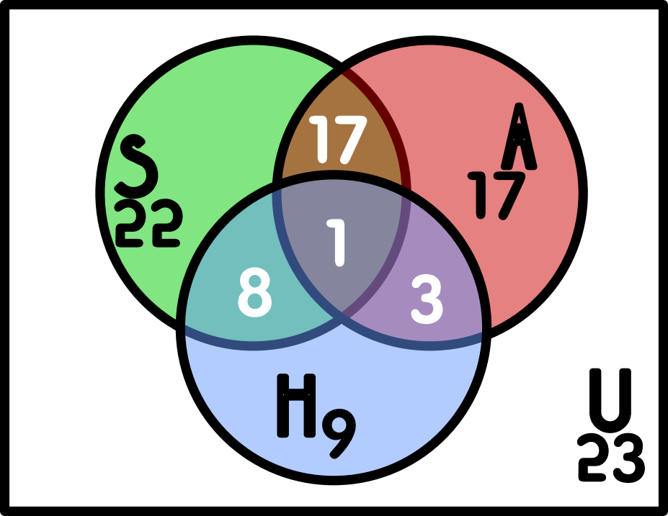
(b) The Final graph should look something like this one,
Let,
S = sociology students
A = anthropology students
H = history students

Hint: “2000 problems” book’s 1.175 or above questions.

